**Assignment-2**

**Assignment given date: 1st June**

**Assignment submission date: 30th June**

1. State the differences between list, tuple, set and dictionary in python with examples
2. Write Python code to print below 2 patterns:
3. 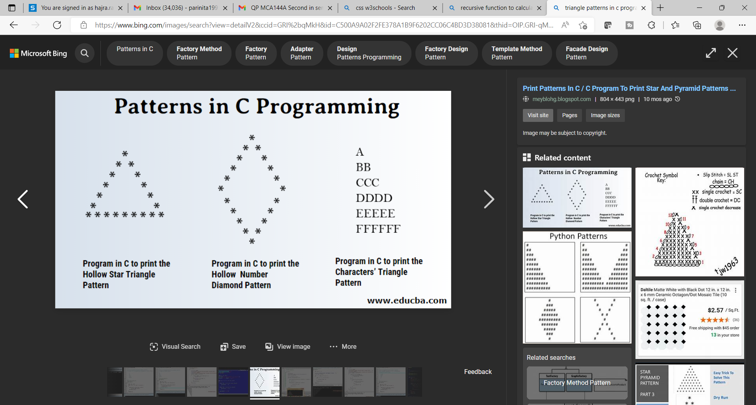
4. 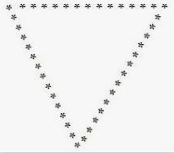
5. Explain default parameter value in functions with example

def fun(Con="INDIA"):

    print(Con+" is my country")

fun("us")

fun()

fun("uk")

1. Explain lambda function with example

def sum(n):

    return lambda x: x+n

o1=sum(4)

print(o1(4))

o2=sum(3)

print(o2(4))

1. Given a list of elements, perform grouping of similar elements, as different key-value list in dictionary.

Input : test_list = [4, 6, 6, 4, 2, 2, 4, 8, 5, 8] Output : {4: [4, 4, 4], 6: [6, 6], 2: [2, 2], 8: [8, 8], 5: [5]}

from collections import defaultdict

test_list = [4, 6, 6, 4, 2, 2, 4, 8, 5, 8]

print("Original:",test_list)

res=defaultdict(list)

for ele in test_list:

    res[ele].append(ele)

print(dict(res))

1. Write a program using a function which takes arbitrary arguments, checks whether all arguments are numbers and returns the second largest element.

#import math

ls=[]

def fun(*numbers):

    for number in numbers:

        if(number.isnumeric()):

            ls.append(number)

        else:

            print(number," is not a number")

fun('4','1','6','9','8','hello')

'''

#print(ls)

#ls=list(set(ls))

'''

ls.sort()

print(ls)

print("second largest element is",ls[-2])

1. Differentiate between passing mutable and immutable objects to function, with example.

def myFunc(args):

    args[2]=9

l = [4,'6','7',2]

T = (4,'6','7',2)

myFunc(l)

print(l)

print(type(l))

print(type(T))

#myFunc(T)      #immutable

# print(T)

1. Explain the difference between:
2. Break and Continue
3. For and While Loop
4. Elif and Nested If
5. What is the use of id() function in python?

The id() function **returns a unique id for the specified object**. All objects in Python has its own unique id. The id is assigned to the object when it is created. The id is the object's memory address, and will be different for each time you run the program

1. What is the use of Pass Keyword in any function?

The pass statement is a null statement. But the difference between pass and comment is that comment is ignored by the interpreter whereas pass is not ignored.

The pass statement is generally used as a placeholder i.e. when the user does not know what code to write. So user simply places pass at that line. Sometimes, pass is used when the user doesn’t want any code to execute. So user can simply place pass where empty code is not allowed, like in loops, function definitions, class definitions, or in if statements. So using pass statement user avoids this error.

1. What will happen if you call any function with more or less arguments than required?

**ANS 11.** TypeError: required positional argument: